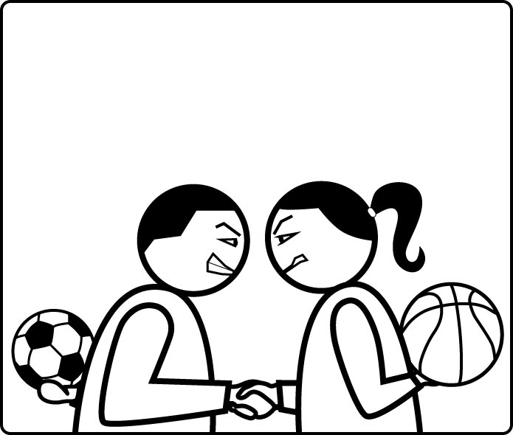

SOCIAL SPORTS
–
Play Your Friends !

Design by Frédéric Fourcade
for Facebook, on Web and Mobile plateform

Storyline:
You start being a poor and unrespected manager. Create the most competitive teams with your friends, climb the local and global ladder, and become a (very) rich and (very) respected manager. Use your hard-earned money to buy cheap and temporary boosters, or not-so-cheap but powerful or constant power-ups. From one-time illicit medicine, to full-time band of cheer-leaders (it's good for mental attributes).
Taunt your opponent at the end of each match to try to increase your psychological upper hand over him, but beware if he can find the right reply and turn your attempt to his own profit. Get more taunts and replies as you progress through the game.
Show the world how wealthy you are by improving the look of your personal office. Get some of the most luxurious items by unlocking and buying them (piece of art, luxury sports car, nice desk, exotic plants, etc...)

Summary : Win games to make money, then unlock and improve your personal achievements.

Gameplay basic mechanics:
The manager can compose teams from a pool of players created from his own facebook friends' profiles. Those players are created only once, so their stats in-game are shared between every manager having these same facebook friends.
The stats are generic physical and mental attributes (like “jump”, “speed”, “left” and “right hand dexterity”, “left” and “right foot dexterity”, “will”, “vision”, “intelligence”, “luck”, etc...). They are not directly related to the different sports available, therefore the manager must learn how they influence each action in each sport. The game basic mechanic relies on assigning the right people to the right role in the right sport.
Once the manager has created a team, he must challenge other managers in a given sport, and from the result and individual players' performance, he can deduce which assignments were right, and which were wrong.
After each game played, the players improve some of their stats depending on their usage. The stats of the same player in other managers' team are also improved, since the profiles are unique and shared.
The manager can also make profit of other managers' choices to improve his own choices, especially when the other manager is using the same players (which are based on common facebook friends).

Summary: Basic mechanic is to find how to optimize usage of available players, because stats influence on the match result is (delibarately) not obvious.

Gameplay advanced mechanics:
In order to give the game more diversity, one manager can buy game-changers with his coins. Coins are earned when playing matches. The manager can earn more coins by winning the match or using a dedicated booster (like a bet).
These boosters are two kind : the single-use ones and the permanent ones. Obviously the second ones are more expensive than the first ones. The manager has just a limited amount of available slots to create his “deck” of permanent boosters (this adds a twist of strategy to the game). On the other hand, the single-use boosters are only effective for the next game, but the manager can use as many as he wants.
Most of the boosters will boost the manager's players' performance in the field, but some may be used to counter the opponent's own boosters. For example, for half the price of an offensive booster, the manager can buy a defensive booster that annihilates the offensive boosters of the opponent. Problem is, if the opponent has not set any offensive booster, the money for the defensive one will be lost (cf. Blood Bowl).
Other boosters might have effects on other consequences than the match performance (double XP, double coins for a win, better player progression, etc...).

Summary: The manager can buy boosters to increase his winning odds, for a one-time use or for permanent effect. There are also defensive boosters to counter opponent's boosters. Finally some boosters can change the rewards of the match.

Gameplay bonus mechanics:
In addition to the previous basic and advanced mechanics (all necessary), we could have some other mechanincs to add some fun to the game and/or increase the feel of friendly competition between players.
The domination and taunt systems are that kind of mechanic : a manager has a unique domination score against each opponent he challenged. This score is mostly based on the results of these specific matches, and gives the manager with the upper hand an advantage at winning the match. At the same time, the rewards are lower for the dominating manager, than if he was under the psychological domination of his opponent. This would push the dominating player to find other opponents to seek better rewards, or rather stick with opponents under his domination for easier wins.
To influence this domination, the winning manager can taunt his opponent after the game (like post-game declaration in real-life), by choosing a taunt among a list dependant on his own XP level. His opponent will then receive the notification, and will be allowed to reply from a list of replies, also dependant on his XP level. The manager who wins this psychological challenge will move the domination score to his advantage.
Note that the taunts and replies list will be also populated by meeting people who use them against the manager (cf. Secret of Monkey Island).

Summary : One extra feature would be a psychological domination score for each pair of managers. It would influence the course of the game and also, inversely proportional, the rewards of the game. This domination score would change depending on game results, but also the taunt challenge system.

Social/viral aspect:
The main social aspect of the game is that the manager actually play with his friends, that is to say that his friends are people in the gale. It's kind of like playing sports with and against your friends. The fact that he can (and is enticed to) play against his friends creates a viral loop similar to the one SongPop achieved with great success. Some features are added that may improve this social aspect, like a player's boost when the corresponding facebook user is also a manager, or the taunt fight.
One important thing is that each player profile is unique and make the corresponding facebook user have one and only one avatar in the whole game. It creates a coherent world within the game, and give facebook users a life in a game they might not even be playing. It could allow classifications, leaderboards, etc... based on player performance.
On the viral side, in addition to all that has been said above, there is the fact that the manager can be challenged, even if he is not connected and haven't play for a while. There is no such thing as a gift system, since the only currency is coins, and coins are gained by quickly and simply play a match. But, since the number of free challenge per day is limited, there will be an “ask to be challenged” button to send notifications to friends.
As a whole, the game is a competitive and a cooperative one . Competitive because you play against other players, and try to beat them to get more rewards. Cooperative because the managers share progression of their teams' players when the users share the same friends, and also because one manager can learn from other managers' choices. This should eventually (and hopefully) create spontaneous discussion between players (like SongPop do).

Summary: creating a single player for one facebook user makes a coherent world. Using your friends as players should create an emotional bond with the game. Playing against your own friends should create a viral loop.

Game-changers:
First, a word to say that there will be a few items/boosters the player can buy to quicken his progression through the game (like unlock one or all players, unlock new sport).
The other game-changers have a direct influence on the matches themselves. They are of two types: permanent ones and “use-only-once” ones. The permanent ones would have an influence on the whole team or on some match variables. The manager can buy as many as he wants, but he can activate only a small number of them at the same time (like rings in a RPG inventory, cf. Diablo). It adds a twist of strategy while keeping balance in the game. The “use-only-once” boosters have an effect on the next match only. They can relate to one member of the manager's team (but not the opponent's same team member). They can also influence the whole team (stamina, luck). There will also be some boosters that are actually supposed to cancel any opponent's booster; they are cheaper, but can be useless (cf. Blood Bowl).
An important, but difficult, aspect of this game-changers is that they must have personnality. They should be fun (cf. Blood Bowl) and/or realistic (cf Off the Ball 2).

Summary: The game-changers have an influence on the matches resolution, and should allow weaker players to increase their chances of victory against better players. And they must be fun and/or realistic.

Instant rewards:
Instant rewards happen when the manager plays a match. Either he loses or wins, he'll gain coins, XP, his players will progress (depending on their performance), and he will progress through his players' unlock list. Although winning makes this progression faster, especially if he wins against (supposed) superior opponent.
The coins are used to buy everything that can be bought: boosters, tokens, unlocks (which could actually be done via boosters/items).
XP will help the manager reach new levels. Levels make the manager better in managing his teams, therefore making his teams better overall, and allows to improve his personal office with new stuffs. This could also grant him new options in-game, like playing more for free (TBD).
Players' progression makes them slightly better in stats they have efficiently used during the match. The progression is shared with all managers playing with these same players.
As the manager plays matches (or it could be based on XP, TBD), he unlocks more and more of his friends as playable in-game, giving him a larger choice, and a need for a better understanding of the game.
The real player will also progress as he understands better how to efficiently use his team members. By unlocking new players, he gets a bigger “deck” from which to pick his players (cf. Guild Wars).
Finally, there will be achievements to unlock, which, in addition to displaying a beautiful trophy showcase and give the manager some defined stuff to accomplish, can unlock new stuffs (cf. Super Smash Bros Brawl).

Summary: There are multiple instant rewards happening when playing a match. They are all used to improve the gameplay in various ways.

Long-term rewards:
As partially explained in the previous section, some rewards are granted when the manager reaches specific career milestones (it could be a new level reached, a number of matches played or won, a total amount of coins earned, etc...).
These are rewards that should be used to show the world (or at least his friends) how good he is at this game. Among them are achievements, which are displayed in the trophy showcase of his office. His office should reflect his success (wealth) and therefore the time he has spent on the game (every manager should progress toward this goal, even if they lose most of the time; winning just makes it faster).
The size of his players' “deck” (the number of unlocked friends ingame) is also a mirror of his success and/or time ingame.
There could also be some long-term rewards that would enrich the game experience, like unlocking new items to purchase, new sports, new taunts and replies.

Summary: The long-term rewards are mainly here to show the player success as playing the game, but could also unlock new features to improve the game experience.

Economy:
The game economy is based on coins. The coins are gained by playing matches. Losing should grant the manager enough coins to buy cheap boosters. Losing all his daily free matches should allow him to buy one big or several small boosters.
Buying a new token to play again should cost more than the amount of coins earned for losing, but less than the reward for winning (so that buying a new token is a bet on the player's future win).
Unlocking a new team member should be a little expensive, but buying several at the same time should be exponentially expensive (but there will be a fair price for buying the “unlock all at once” booster).
Checking a locked player stats should be very cheap, but not free.
Coins can never be used to cheat on the manager's success, only to quicken or ease it.
Finally, packs of coins are the only thing users can buy with real money.

Summary: Coins are gained everytime the manager plays. They should allow him to quicken or ease his success, but never lie about it. It's also the only way to spend real money.

References:
- Football Manager:
  - Team member's physical and mental attributes, and how the game uses them to resolve a match.
  - Team building screen (Not Yet Defined).
- Elder Scrolls:
  - Player progression: stats shall increase when used with success.
- La Brute:
  - Quick and server-oriented match resolution.
- Guild Wars:
  - Team building from a larger deck of available players.
  - Permanent boosters set from a larger amount of available boosters.
- Diablo (or any RPG with an inventory system):
  - The use of a limited number of permanent boosters, to choose among a larger selection of them (like rings in RPG inventory)
- Blood Bowl/Off the Ball 2:
  - Pre-game boosters (offensive and defensive)
  - Humour
- SongPop:
  - Viral loop
  - Challenging friends.
- Demon's Soul:
  - Indirect cooperative gameplay.
- Civilization II & III:
  - Office improvements through manager progression (cf. palace)
- Super Smash Bros Brawl:
  - Achievement showcase which unlocks bonus elements for the office.
  - Hidden achievement system.
- The Secret Of Monkey Island:
  - Taunt system

